Log in button

Forgot your password button

Cart area?

Checkout button

Home, request, new products, specials, help

New div – create an account, my account, logoff

New div – receive email specials, subscribe button, click here for details, place to enter email address

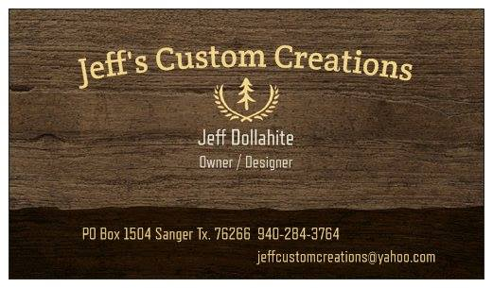

For products list, should be menus that you can scroll over and show other options which will give you links to specific spots. Maybe do check boxes?

Paragraph

Links

Paypal payment available

Contact info